Handwriting Apps
ABC Clamp Monkey  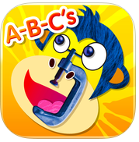 | iPhone/ iPad | Construct letters and words from shapes (sticks and circles). | 0.99
Dexteria   | iPad | Fine motor/visual motor skill development and handwriting readiness | 4.99
iWriteWords  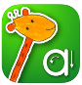 | iPhone/ iPad | Letter/number identification and formation app. | Lite/2.99
Letter School   | iPhone/ iPad | Highly interactive letter formation app providing numerous different animations to show direction of letter formation. | Lite/4.99
Write Your Name   | iPad | Letter formation practice; app provides ability to create activity with letters of a childs name to practice writing their name | 3.99
Ready to Print  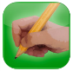 | iPad | Provides pre-writing activites and upper and lower case letter formation practice. | 9.99
ABC Pocket Phonics Lite  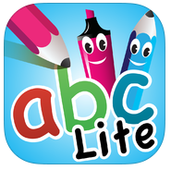 | iPhone/ iPad | Lite version of letter formation app | free/2.99
Touch and Write Cursive Letters   | iPad | Letter and formation practice for cursive handwriting. Provides a variety of mediums and backgrounds. Detects accuracy of letter formation; Create your own word list. | 2.99
Touch and Write   | iPad | Letter and number formation practice providing a variety of mediums and background papers; word practice provided | 2.99
Alphabet Tracing  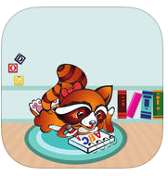 | iPhone/ iPad | Features train and other animated prompts to show direction of letter formation. | Free
Abby Pal  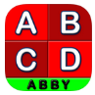 | iPhone/ iPad | Provides animated tracing and strokelines and directions; letters only | lite/1.99
Zaner- Bloser Manuscript  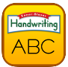 | iPhone/ iPad | Letter formation, number formation; animated letters, practice letters out of order | 1.99
iTrace  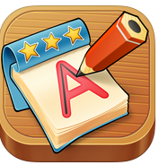 | iPad | Guided practice with reducing levels of support for learning letter and number formation. Different styles of letter formation available. Features writing individual names and words. Practice letters out of sequence. | 3.99
Little Writer Pro  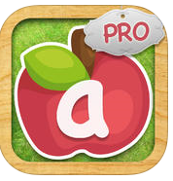 | iPad | Tracing activities for shapes, letters, numbers and words. Customizable by difficulty and direction of formation. | 1.99
HWT - Wet Dry Try  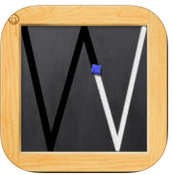 | iPad | Handwriting Without Tears app for letter formation. Additional single user +3.99; Double user +7.99; additional charge for additional users. | 6.99
Wet Dry Try - Live Insights   | iPad | Live insights gives instructors information about student progress | free
Letter Workbook  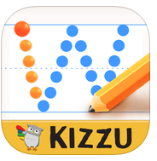 | iPad | Letter formation, word writing workbook; | Free/1.99
ABC Easy Writer Cursive  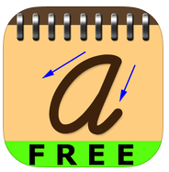 | iPad | Cursive writing practice; Speaks letter, shows trace ; presents letters in order, free only Upper case letters | free/
CursiveWriting HD  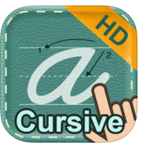 | iPad | Cursive writing practice; Speaks letter, strokelines, chose practice letters from palette; words, sentences | 0.99
Cursive Practice  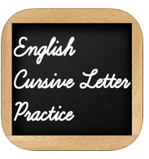 | iPad | Cursive practice, upper/lower case, numbers, words, doodle board; practice letters repeatedly when typed in, shows lead in stroke, ink color options; preferred cursive app | free
ABC Cursive Writing (Deep Pockets)  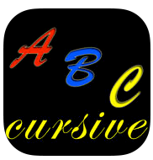 | iPhone/ iPad | Cursive practice, upper/lower case, numbers, words, sentence; offers shuffle for letter practice, erase, several colors ink, line width , show lead in stroke | 0.99
Cursive Writing (Horizon)  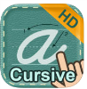 | iPad | Upper case lower case cursive writing app; color pens, show/hide lines; provides numbered arrows; most letters have lead in stroke (except a, d, c, g, q) | free/.99
Writing Wizard  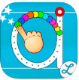 | iPad | Letter and number, word handwriting apps with customization of types of font and method used. Motivating for students. | 4.99
Cursive Writing Wizard  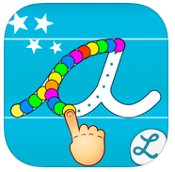 | iPad | Cursive letter formation app from the popular Writing Wizard app. Can trace any word. App is customizable. | 4.99
Shapes Touch and Write  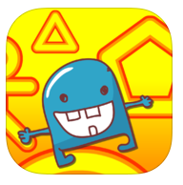 | iPad | Create by Fizzbrain, developer of Touch and Write for manuscript and cursive. Provide practice for drawing developmental lines and shapes. | 2.99
Zaner Bloser Handwriting Cursive  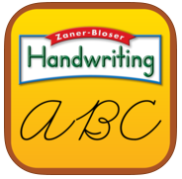 | iPad | Letter formation, number formation; animated letters, practice letters out of order | 1.99
Start Dot Handwriting  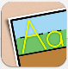 | iPad | Handwriting for 3-6 year olds. Uses earth, grass, sky visuals for placement of letters. Wide error for beginners. 2 learning styles: guided or alphabet. Free download worksheets available on website. | 4.99
Handwriting and Sight Words Tutor  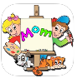 | iPad | Practice writing words using this app with Dolch words. | free
TV Teacher  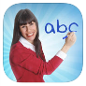 | iPad | Letter formation, phonics app with video modeling for ages 2-7 year olds. Based on TV Teacher DVD instruction. | free/4.99

