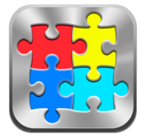
App Screen
Navigate through Screens – Swipe across the top of the app to move between Categories. Move between users by swiping across the bottom of the screen. You can also access users from the More icon in the bottom menu.
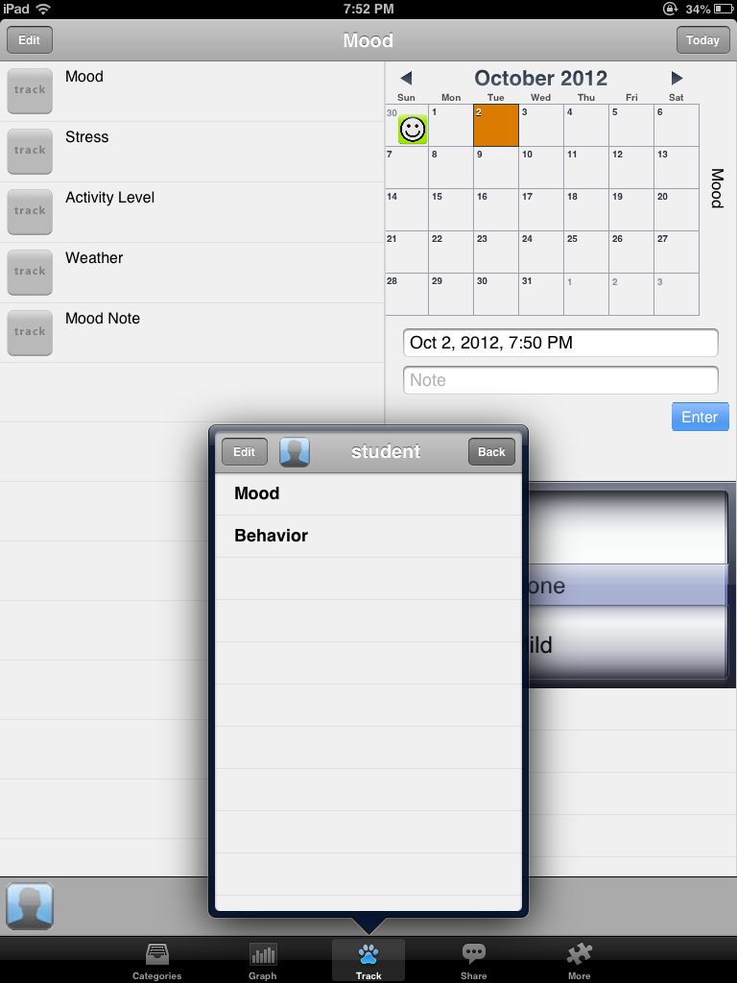
App Menu- Bottom –
Categories- Add new categories by tapping the bottom menu button
Graph – This menu item switches to the graph view after ratings are entered
Track- Enter ratings and edit items to be rated (goals or behaviors you are tracking)
Share – Allows you to share the category data
More – Provides tools to edit set up of items, select or edit persons, turn badge counter on/off, clear data, set passcode, help
Creating a Person
- Go to More tab
- Tap Select or edit persons
- Select a person listed or if there is none in the list tap Edit to add a “student”
- Tap Done
Creating Categories for a Person or User
- Tap Category at the bottom left of the screen
- Tap Edit, add a new category e.g. Mood or Mood 2 , tap Save.
- Select Mood 2 – A new screen is presented (name of the category is at the top of the screen)
- Tap Edit – Tap Create New Item
- Select a rating scale for the item- Select the Pain rating
- Screen of the Pain rating is presented
- In Enter item name here – type Mood - AM
- Go to Edit Labels
  - Elated
  - Happy
  - Okay
  - Sad
  - Upset requires consoling
  - Inconsolable
- Set the Goal you want or expect the student to be at (Happy or Okay)
- Click Add to badge counter.
- Select the category or categories you want the rating to be shown in (Mood 2 or your choice). Here is where you can add the category to another screen to complete.
- If you wanted to copy the item you can edit the item and “Copy item at the bottom of the screen”; Copied item will be displayed in the items as copy, edit the name by taping and editing the text.
- Tap Done when editing is finished.
Track Menu (footprint)
This is where you collect your data after you have created goals for your “person” or user. This can be done in two different ways:
- Tap on the item to track on the left then tap on the date you are entering a rating in the calendar; you can go back and enter information on past days
- Select the rating then tap Enter. Your rating will be listed. You can enter more than one rating in the item.
- Enter a note about the mood or any significant situations about the students’ mood. This will be included with the rating entered.
- If you want to delete an entry swipe over the entry. A Delete options is provided.
- When an item is rated the rating is displayed in the item or goal list.

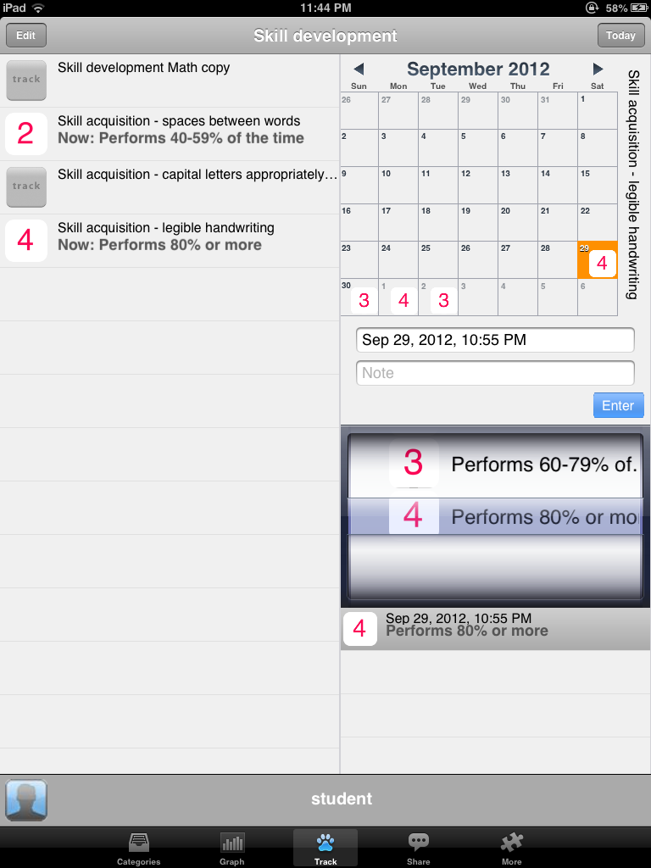
Enter one rating to 3 or 4 days items in your Mood category of your Person or Student. Add notes to the ratings entered. Note the entries by day, and the listing of your entries below the rating scale.
Graph Menu – Tapping the Graph menu at the bottom of the screen will convert the rating to a graph.
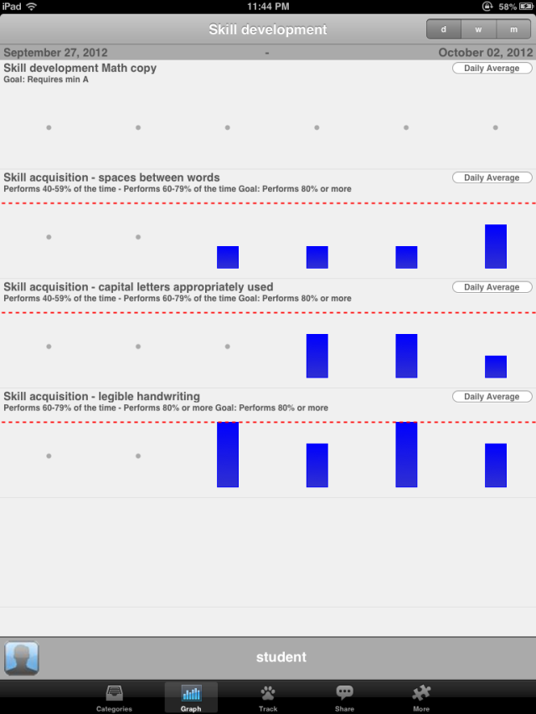

Tapping on the center of individual graphs provides different views of the data. At the top right of each of the items you can choose to view the data by toggling between Daily average, min., maximum, last data. Depending on what kind of information you are collecting and what kind of information will be meaningful this will be different. You can also display the information by daily, weekly or monthly (top right of screen).
Share Menu
The Share menu – provides the capabilities of sending the data categories or items rated using HTML or CSV format. Data can be sent by daily graph, weekly or monthly graph.
At the top of the screen you will see the category or Item you are sending. At the top right of the screen you have the choice of sending Items or Categories. Tap each of these to see what can be emailed. Typically List of each entry and note is sent with All Data selected in the Timeframe and CSV selected in the Format.
When all of the data choices are made, Tap Send Category Data
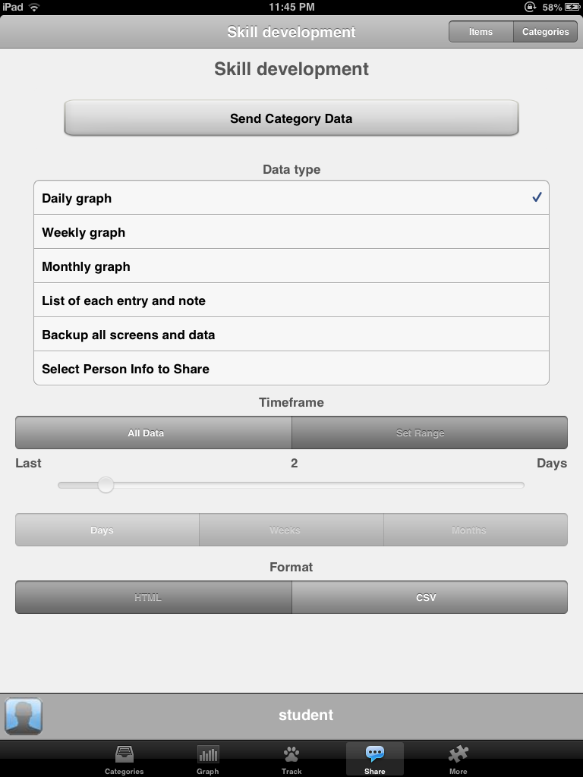

More Menu- Provides additional editing and set up of items and selecting and editing persons.
Other features available:
- Setting clearing hour
- Set screen passcode
- Color settings
- Purchases – in app purchases if you want to add additional persons into the app to track
- The Edit Set up allows you to customize the ratings, using pictures, from your photos in the ratings
